

Assignment Cover Sheet

advance programming

To be completed electronically by the student and submitted with each piece of work. Please upload this completed cover sheet via Turnitin.

Assignment Title:

Tutor: Muhammad Ali
Student Number: 03-24-107
Date of Submission: November 5,2025
Details of your submission: Code and Video Link, Assessment Exercise Screenshots and Descriptions, and Python Intermediate Certificate

For an online submission, please enter the URL of where your project files can be accessed (e.g. Google Drive). If a physical artefact, please provide further details on how this project has been submitted to tutors.
- https://github.com/A-kheel/Advanced-Programming-Assessments.git
- https://drive.google.com/drive/folders/1YN8_2sLYad6ny6FjXOQ0zMHHFeTQM1eD

In submitting this assignment, I am confirming that I have read and understood the regulations for assessment, and I am aware of the seriousness with which the institute regards unfair practice.
Please see the academic Unfair Practice Policy for details.

Signed: Date: November 5, 2025

math.py

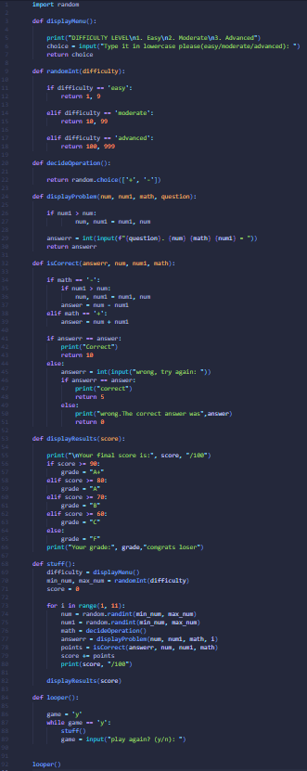

Output:
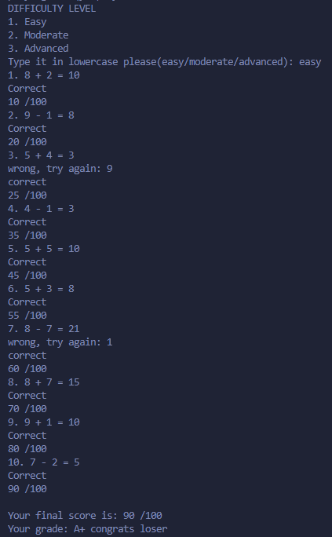
Each function has a specific purpose in making sure that the math questions function properly. The displayMenu function prompts the user to input either easy, moderate, and advanced. Each option determines whether each question is single-digit,double-digit, or triple-digit which is randomly generated through the randomInt function and the operations whether the question is addition or subtraction, is also randomly generated. The displayProblem adds the operations and the numbers and displays them. The IsCorrect function checks if the input correlates with the true answer of the question. The displayResults function calculates the grade and the corresponding score and shows it to the user. The stuff function handles all the variables and makes sure that they run correctly and that they function together. The looper function loops the entire code all based on one input from the user.

alexa.py
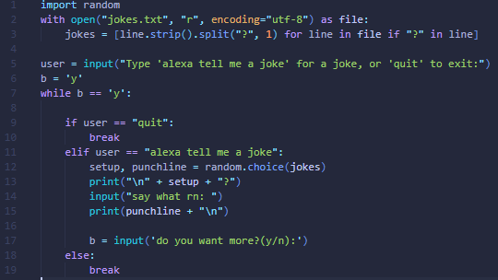
Output:
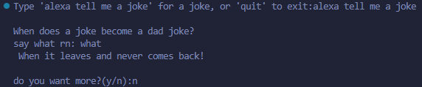

The code starts off importing random and making sure that the text is imported with the correct format; the setup and the punchline. The code is then started by the user input which then starts off the loop which displays the joke and another input from the user and then delivers the punchline. Another input is then prompted from the user which determines if the loop starts off again or it quits.

students.py
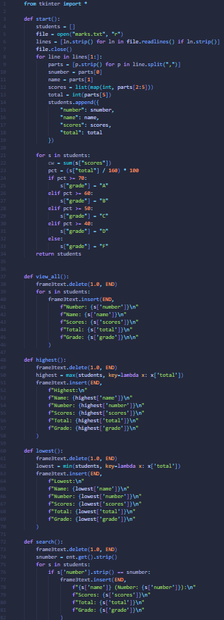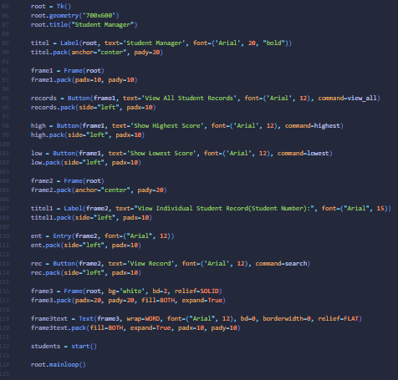

Output:
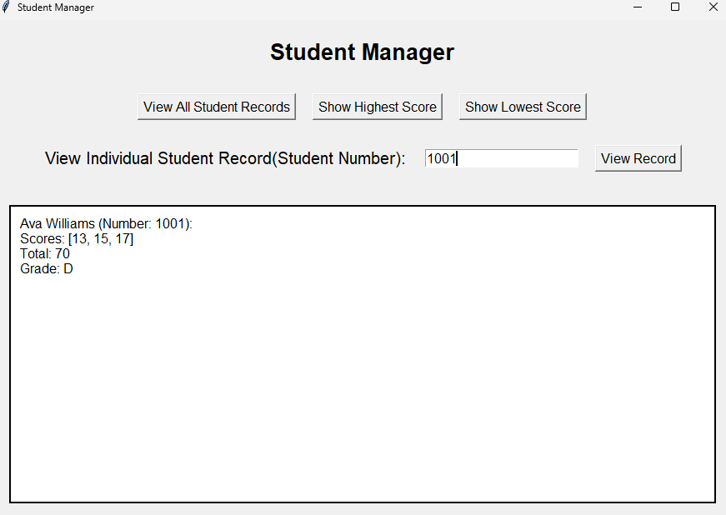
The start function makes sure that the txt file is opened and formatted properly using the number, name, scores, and the total to be properly displayed. In this function there is also another for in loop which adds a new key which is to grade to the students by using the total. The view_all function is connected to the view all button which runs this function and shows all of the txt files in order and in the right format. The highest function is assigned to the button which shows the highest score and does the same thing as the other button but it finds the highest scoring student by making lambda compare all of the totals in the txt file and then the max() shows the highest total and displays it. The lowest function does the same but it uses the min() function. The search function takes the input from the entry widget and displays it. Take note that these previous three functions delete and clears either the entry box and the text frame where it displays the results to make way for the new ones. They also have slight adjustments to make the input more readable like .strip() to remove extra spaces. The user display has 3 total frames where frame one consists of 3 buttons, frame 2 which has a label, an entry box, and another button. Frame 3 has the purpose of displaying the results after each command or a push of a button.

Python Intermediate Certificate
